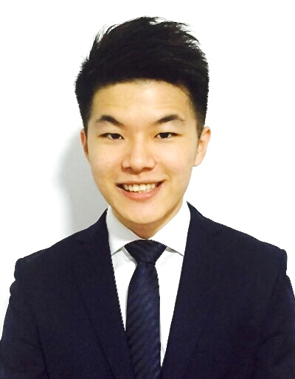
Loh Zhiyuan, Gabriel

Address: Block 312A Sumang Link, #13-187, Singapore 821312
Contact No.: +65 90041344 (Mobile)
E-mail: gabrielloh87@gmail.com

To secure a position in a progressive work environment that will enable me to use my strong leadership qualities and work experiences in making a positive contribution to the organization.

Work Experiences

- Portfolio Finance, Special Investments (Private Equity) – GIC Pte Ltd
October 2015 – Present
- Process Capital Calls and Distributions for Private Equity Investments
- Partner with the Investment and Legal teams on deal funding
- Handle KYC and Corporate Secretarial functions for investment holding companies
- Verify valuation and reporting for investment assets
- Achievement – Exceeded expectations for performance appraisal (Promoted within one year of joining)

- Senior Fund Accountant – BNY Mellon
August 2012 – September 2015
- Preparation and review of Net Asset Values (NAVs) across multiple fund types and clients in accordance to industry standards
- Perform reconciliation of portfolio’s cash and securities holdings
- Preparation of Return on Investment (ROI) reports
- Achievement – Exceeded expectations for performance appraisal (Promoted to Senior Fund Accountant)
- Awards – BNY Mellon Aspire Team Outperformance Award 2014

Non Academic Achievements

- Republic of Singapore Air Force
- Awarded the Sword of Honour as the overall best officer cadet of the cohort
- Best Trainee (20th Mistral Officer Course)

- Ngee Ann Polytechnic
- Represented Ngee Ann Polytechnic in the Worldwide Microsoft Office Excel Specialist Competition 2006
Educational Qualifications

- Singapore Institute of Management
August 2010 – June 2012
- Bachelor of Science (Honours) in Business
- Awarded and Developed by University of London (UOL), UK. Lead College, UOL: London School of Economics and Political Science

- Ngee Ann Polytechnic
March 2004 – June 2007
- Diploma in Business Studies (Entrepreneurship)

Certifications

- Capital Markets and Financial Advisory Services (CMFAS) Certified in Module 1A and exempted for Module 6

- Certified Microsoft Office Specialist for Microsoft Office Excel 2003

System Knowledge

- Bloomberg, Microsoft Excel/ Powerpoint/ Word, Sungard Enterprise, IDC, Spire

Personal Details

Date of Birth : 16 October 1987

Languages Known : English, Mandarin Chinese

Nationality : Singaporean

